**Commercially available RTLS in the market that can be used in acrylic bathtub manufacturing**

* List of commercially available RTLS in the market for indoor use
* **UWB (Ultra-Wideband):**
  + [Decawave](https://www.decawave.com/)
  + [Pozyx](https://www.pozyx.io/)
  + [Ubisense](https://ubisense.com/)
* **RFID (Radio-Frequency Identification):**
  + [Impinj](https://www.impinj.com/)
  + [HID Global](https://www.hidglobal.com/)
  + [Alien Technology](https://www.alientechnology.com/)
  + [Siemens](https://www.siemens.com/global/en/products/automation/identification-and-locating/rfid-systems/simatic-rf300.html)
* **Camera (for QR reading):**
  + [Cognex](https://www.cognex.com/)
  + [Keyence](https://www.keyence.com/)
  + [Datalogic](https://www.datalogic.com/)
* **BLE (Bluetooth Low Energy):**
  + [Estimote](https://estimote.com/)
  + [kontakt.io](https://kontakt.io/)
  + [Nordic Semiconductor](https://www.nordicsemi.com/)
* **GPS (Global Positioning System):**
  + [Trimble](https://www.trimble.com/)
  + [Garmin](https://www.garmin.com/)
  + [Topcon](https://www.topconpositioning.com/)
* **Wi-Fi:**
  + [Cisco Meraki](https://meraki.cisco.com/)
  + [Aruba Networks (HPE)](https://www.arubanetworks.com/)
  + [Ekahau](https://www.ekahau.com/)
* Tabular comparison of the available RTLS technologies (Ultra-Wide Band, UWB, RFID, Bluetooth Low Energy (BLE), Wi-Fi, camera, and GPS) based on accuracy, power consumption for battery-operated tags (transponders), range of operation, and localization method

|  |  |  |  |  |  |  |
| --- | --- | --- | --- | --- | --- | --- |
|  | UWB | RFID (passive/active) | BLE | WiFi | Camera | GPS (outdoors only0 |
| Accuracy | 10-50cm | 1m/up to 10m | <5m | <10m | 1cm-50cm | 1-10m |
| Power Cons. | 10-100mW | None/1-100mW | 1-50mW | 10-100mW | 100-500mW | 50-200mW |
| Range | 0-50m | 0.5-1m/up to 5m | 0-100m | 0-500m | 1-10m | 10-100m (outdoors |
| Localization | Time of Flight (ToF), Angle of Arrival (AoA) | None/ Triangulation, RSSI (Received Signal Strength Indication) | RSSI, Triangulation, Angle of Arrival | Triangulation, RSSI | Computer Vision, Image Processing | Trilateration based on satellite signals |

<https://www.awareinnovations.com/2021/03/03/rtls-technology-comparison/\>

<https://www.inpixon.com/blog/types-of-rtls-how-they-work-together-to-create-synergies>

<https://www.sewio.net/uwb-technology/rtls-technology-comparison/>

<https://ubisense.com/rtls-technology-the-ultimate-guide/>

<https://www.wisersystems.com/compare>

<https://www.coxprosight.com/post/rfid-vs-ble-rtls>

* Which technology/technologies can be used in automated bathtub production lines?

Most of the indoor tracking technologies are good candidates to be implemented for asset tracking in the production line. However, since budget is always a concern, it’s better to implement technologies that directly benefit or improve particular parts of the production line rather than use a one-size-fits-all type of solution. For example, we can use passive RFID tags to keep track of which bathtub mold is currently in use. For the acrylic sheets we can use QR codes and camera vision to detect which sheet type (size, color, thickness, texture, etc) is currently in use, and since the sheets are consumables, we don’t have to worry about damaging anything, since only a QR code sticker is stamped on the sheet. To keep track of moving objects (such as forklifts or autonomous robots) or temporary stationary objects (such as pallets), or workers, we can use Ultra-Wideband technology, as it provides better tracking of objects in motion compared to passive RFID or camera. Once the item is packaged and ready to be shipped, we can use GPS for tracking outside the wirehouse.

* Select the components needed to form the RTLS system for the bathtub production line
* Mold warehouse: RFID on both Molds and Warehouse spots
* Acrylic Sheet warehouse: Camera reading QR code stickers on sheets
* Production floor - carts or rail moving the thermoformed sheet around: we can use either RFID or UWB
* Production floor - moving equipment or people: UWB
* Final dispatching warehouse: RFID or UWB for tracking inside the warehouse, GPS for tracking the pallets after dispatching
* Which RTLS vendor do you recommend (recommend three vendors) to be used in the acrylic warehouse, production floor, mold warehouse, and final dispatching warehouse

Mold warehouse: RFID

* [Impinj](https://www.impinj.com/)
* [HID Global](https://www.hidglobal.com/)
* [Alien Technology](https://www.alientechnology.com/)

Acrylic Sheet warehouse: Camera (QR Code)

* [Cognex](https://www.cognex.com/)
* [Keyence](https://www.keyence.com/)
* [Datalogic](https://www.datalogic.com/)

Production floor: RFID and UWB

* For UWB
  + [Decawave](https://www.decawave.com/)
  + [Pozyx](https://www.pozyx.io/)
  + [Ubisense](https://ubisense.com/)
* For RFID
  + [HID Global](https://www.hidglobal.com/)
  + [Impinj](https://www.impinj.com/)
  + [Alien Technology](https://www.alientechnology.com/)
* What features (from the above list) of the RTLS do we need to consider when purchasing and deploying them for bathtub manufacturing applications?

The most important features to consider are range and power consumption. Range is important because we need to make sure the entire warehouse floor and production floors are covered, and power consumption is important because we want the technology to run for extended times without having to replace batteries or recharge. Accuracy is of lesser importance since it will be cheaper to install multiple access points that RTLS devices can ping to than using high accuracy devices. Also, since warehouses have small floor area relative to the range the technologies can cover, accuracy degradation will not be a problem.

* Can we use the same RTLS technologies for warehouses and production floors? Or we need different technologies to be deployed?

Using the same RTLS technologies everywhere in the warehouse and the production floor is not optimum, since stationary and moving objects require different asset tracking technologies, for example, we can implement passive RFID tech in mold warehouse, and computer vision using cameras for tracking the acrylic sheets with QR codes. On the other hand, it’s better to use more sophisticated solution for tracking moving assets in the production floor such as forklifts, autonomous robots, carts moving the thermoformed sheets, and workers using longer range technology such as UWB, BLE or WiFi.

**Network architecture and infrastructure (hardware and software) needed for implementing RTLS in a bathtub manufacturing company**

* Network architecture for each technology and each application (warehouses and production floor) if they are different.

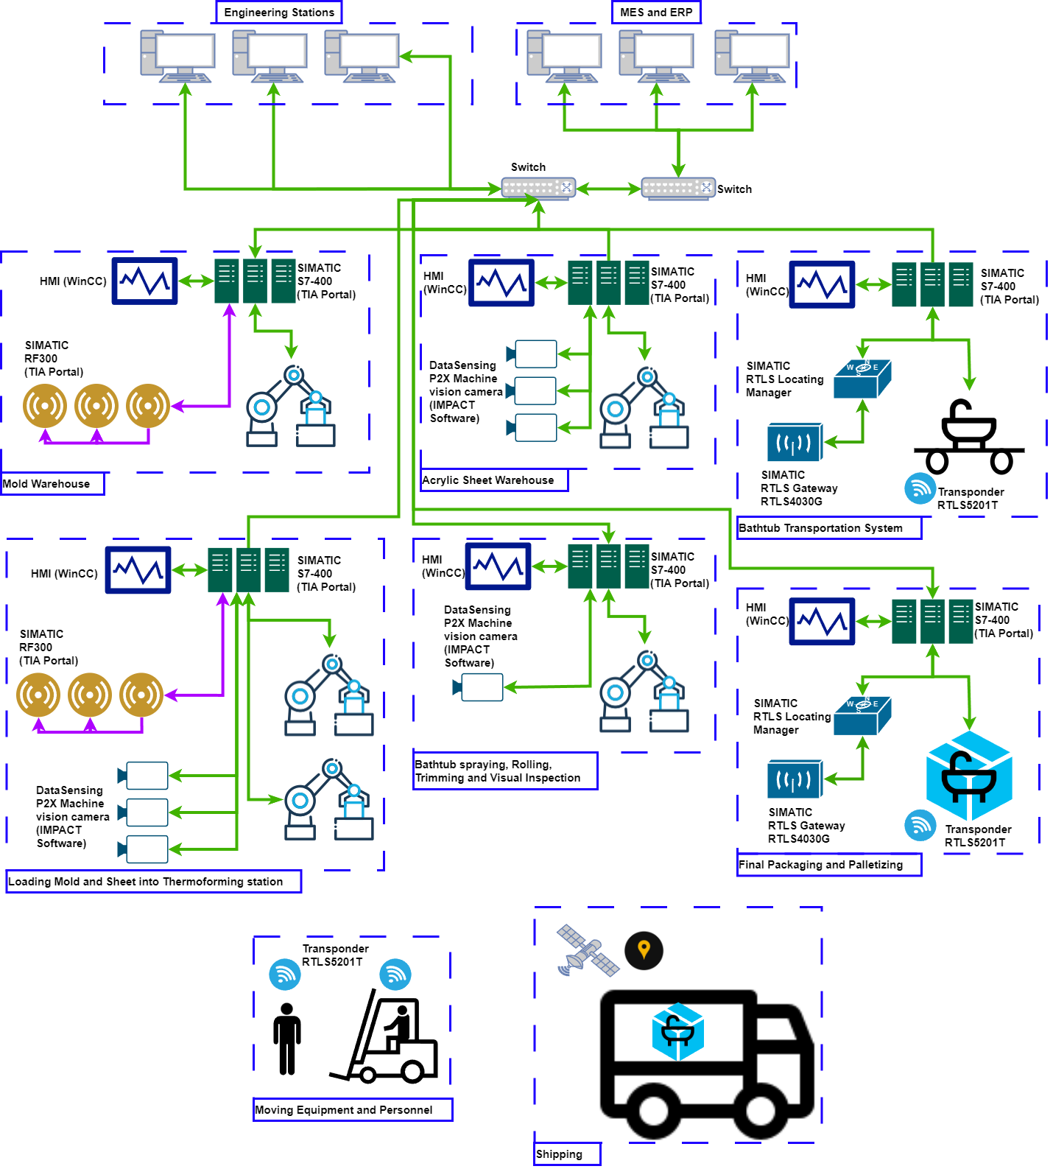

**Localization Methods**

Different technologies use different localization methods,

UWB: Time of Flight (ToF), Angle of Arrival (AoA)

RFID (Passive/Active): None/ Triangulation, RSSI (Received Signal Strength Indication)

BLE: RSSI, Triangulation, Angle of Arrival

WiFi: Triangulation, RSSI

Camera: Computer Vision, Image Processing

GPS (outdoors only): Trilateration based on satellite signals

Time of Flight (ToF)

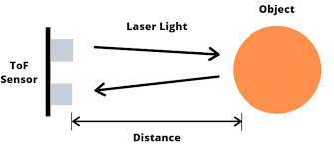

https://www.seeedstudio.com/blog/2020/01/08/what-is-a-time-of-flight-sensor-and-how-does-a-tof-sensor-work/

Angle of Arrival (AoA)

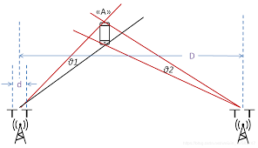

https://e2e.ti.com/support/wireless-connectivity/bluetooth-group/bluetooth/f/bluetooth-forum/856500/boostxl-aoa-how-to-calculate-the-coordinates-of-the-node-to-be-located-by-the-aoa

Triangulation

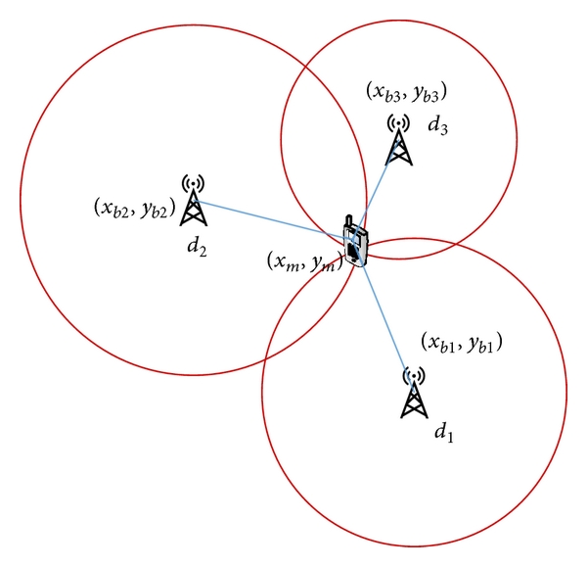

https://www.researchgate.net/publication/281753273_Mobile_Localization_Based_on_Received_Signal_Strength_and_Pearson's_Correlation_Coefficient

RSSI

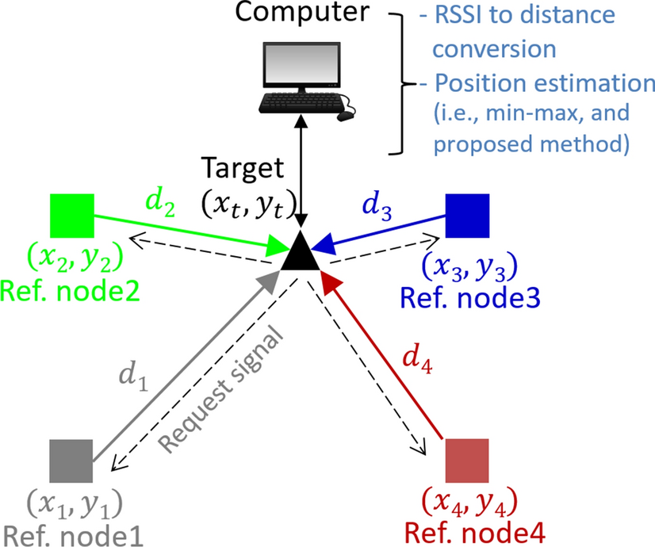

https://www.researchgate.net/publication/374334229_Enhancement_of_an_RSSI-Based_Min-Max_Localization_Method_with_Forbidden_Zone_Consideration_for_Indoor_Corridor_Environments

Computer vision and Image processing

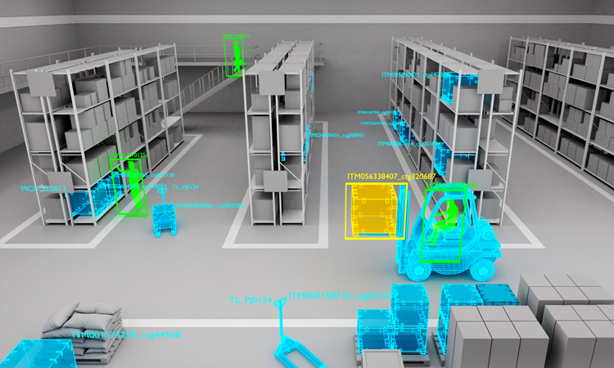

https://appen.com/blog/how-to-create-training-data-for-computer-vision-use-cases/

Trilatiratation based on satellite signals

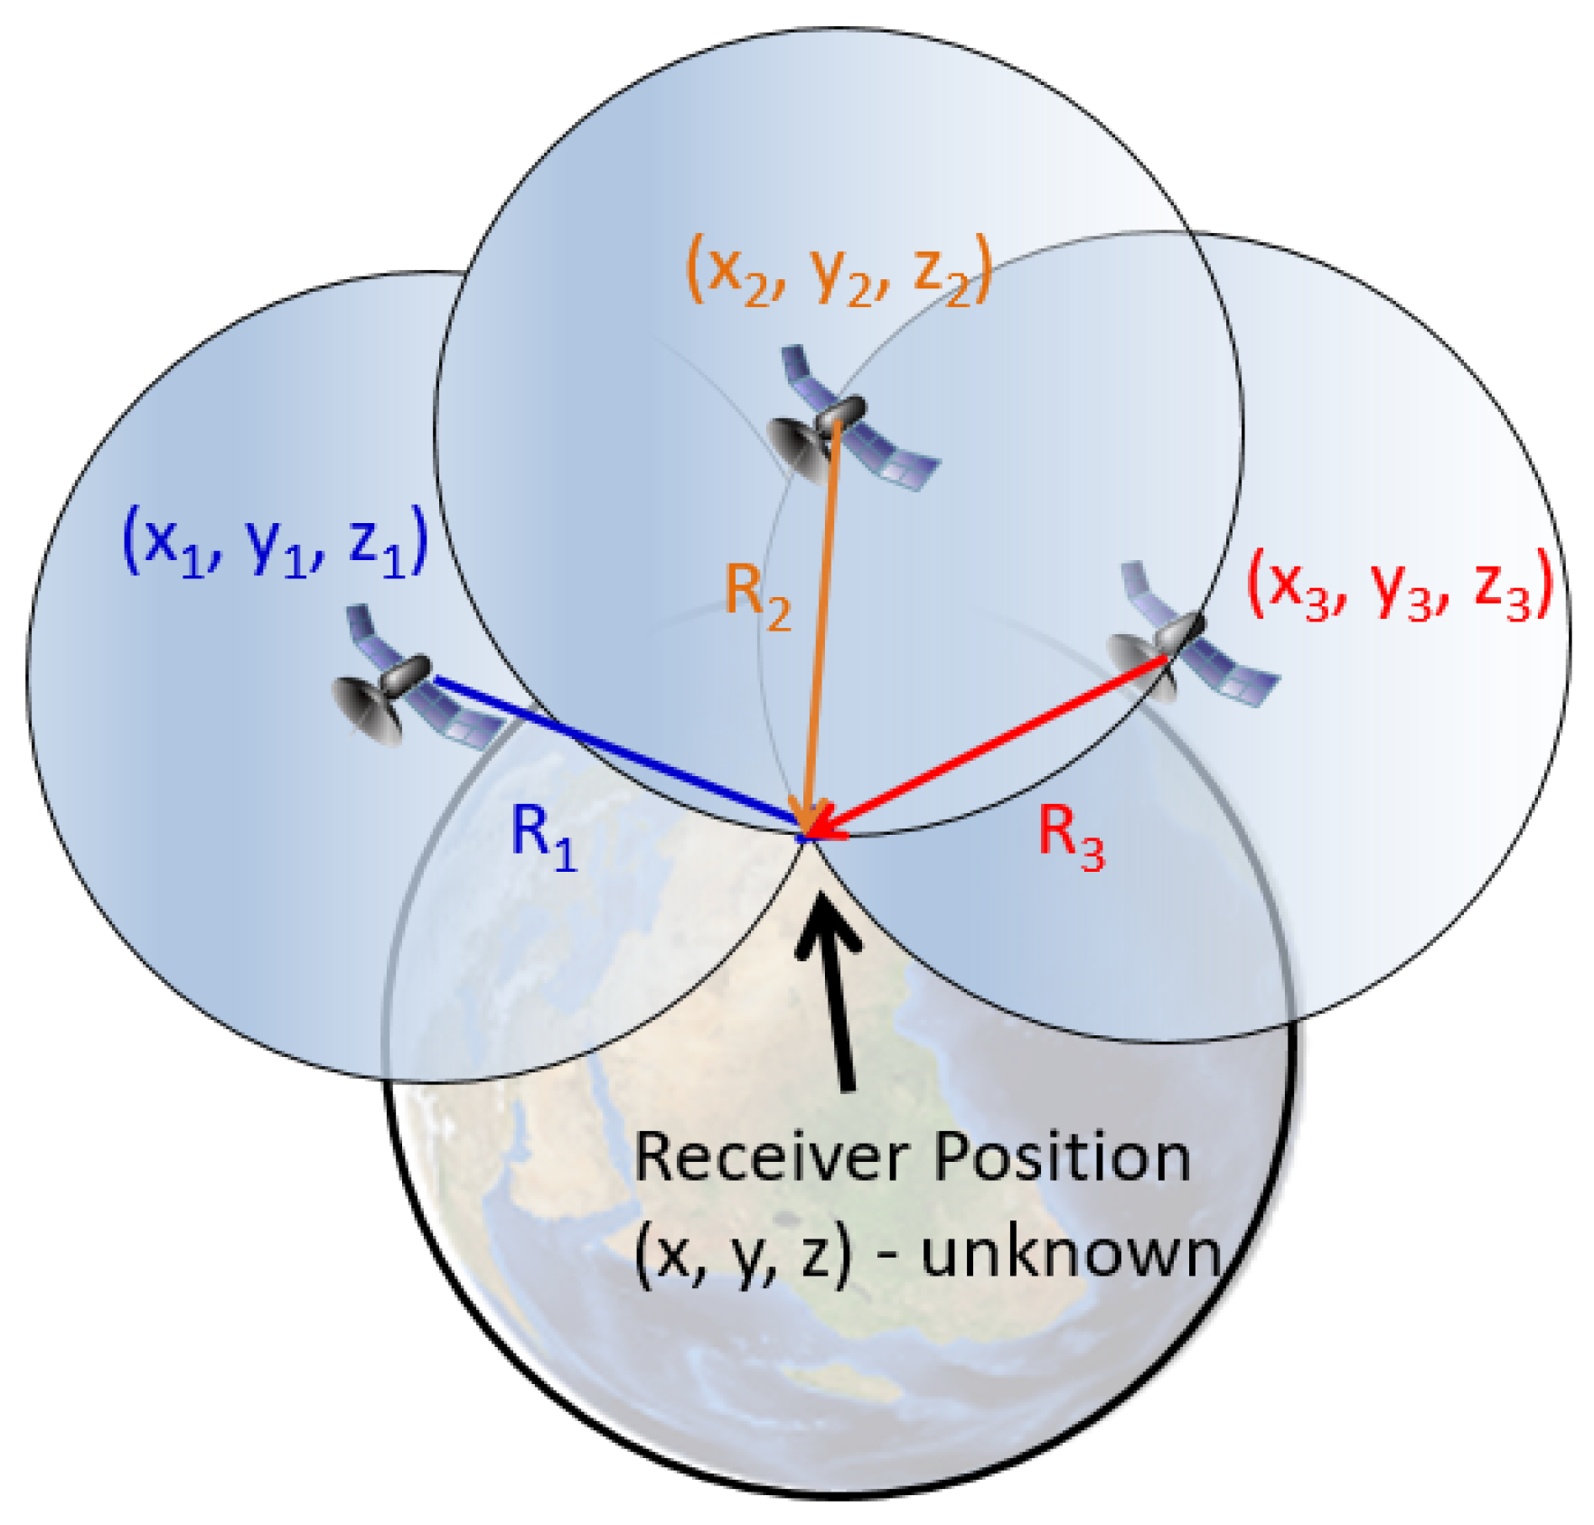

https://encyclopedia.pub/entry/history/compare_revision/52103/-1

**Benefits of RTLS in Smart Manufacturing of Acrylic Bathtubs**

* How RTLS increases the efficiency, throughput, productivity, transparency, and safety of the above procedures in bathtub manufacturing

1. **Efficiency:**
   * **Asset Tracking:** RTLS enables real-time tracking of materials, components, and tools, reducing the time spent searching for items. This ensures that everything is in the right place at the right time.
   * **Workflow Optimization:** By monitoring the movement of workers and materials, you can identify bottlenecks and streamline workflows for maximum efficiency.
2. **Throughput:**
   * **Predictive Analysis:** RTLS data can be analyzed to predict potential delays or issues in the manufacturing process, allowing for proactive measures to maintain a steady throughput.
3. **Productivity:**
   * **Resource Allocation:** With accurate real-time data, you can optimize the allocation of resources, ensuring that workers have the tools and materials they need to be productive.
   * **Process Monitoring:** Track the progress of each manufacturing step to identify areas where productivity can be improved or where additional training may be beneficial.
4. **Transparency:**
   * **Real-Time Monitoring:** Provide stakeholders with real-time updates on the status of each manufacturing stage. This transparency can enhance communication and collaboration between different teams or departments.
   * **Traceability:** RTLS can help in creating a detailed history of each bathtub's production journey, from raw materials to finished product, enhancing transparency for quality control and compliance purposes.
5. **Safety:**
   * **Employee Tracking:** In case of emergencies, knowing the real-time location of employees ensures a quick response. Additionally, you can set up alerts for restricted or hazardous areas to enhance worker safety.
   * **Equipment Monitoring:** Monitor the status of machinery and equipment in real-time to identify potential safety hazards or maintenance needs.

* What can be the driving force behind using RTLS in bathtub manufacturing

1. **Efficiency Enhancement:**
   * **Asset Optimization:** RTLS allows for real-time tracking of materials, tools, and equipment, minimizing the time spent searching for resources. This optimization contributes to a more streamlined and efficient production process.
2. **Cost Savings:**
   * **Resource Management:** Improved visibility into the location and usage of resources helps in optimizing their allocation. This, in turn, reduces waste and lowers operational costs.
3. **Quality Control:**
   * **Real-Time Monitoring:** The ability to monitor the production process in real time enables early detection of defects or deviations from quality standards. This proactive approach enhances overall product quality.
4. **Workforce Productivity:**
   * **Task Optimization:** RTLS can be used to analyze and optimize workflows, ensuring that workers are engaged in tasks that align with their skills and availability, thereby boosting productivity.
5. **Safety and Compliance:**
   * **Emergency Response:** In the event of an emergency, knowing the real-time location of workers allows for a swift and targeted response, enhancing overall safety in the manufacturing environment.
   * **Regulatory Compliance:** RTLS can assist in maintaining compliance with safety regulations and standards by providing accurate data on worker locations and equipment usage.
6. **Data-Driven Decision Making:**
   * **Analytics and Insights:** RTLS generates valuable data that can be analyzed to identify patterns, trends, and areas for improvement. This data-driven approach empowers decision-makers to make informed choices to optimize processes.
7. **Customer Satisfaction:**
   * **Timely Deliveries:** By improving efficiency and throughput, RTLS can contribute to meeting production timelines and ensuring timely deliveries. This positively impacts customer satisfaction and can lead to repeat business.
8. **Technology Integration:**
   * **Industry 4.0 Integration:** RTLS aligns with the principles of Industry 4.0, fostering the integration of advanced technologies for a more connected and automated manufacturing environment.
9. **Competitive Advantage:**
   * **Innovation and Differentiation:** Embracing RTLS demonstrates a commitment to innovation and efficiency, providing a competitive edge in the market. It showcases a forward-thinking approach to manufacturing processes.

* How we can calculate or estimate the Return on Investment (ROI) when using an RTLS system?

1. **Identify Costs:**
   * Initial costs (hardware, software, installation)
   * Ongoing operational costs (maintenance, support, training)
2. **Quantify Benefits:**
   * Efficiency gains (time savings, optimized workflows)
   * Productivity improvements (output per unit time, reduced labor costs)
   * Cost savings (resource optimization, inventory management)
   * Quality control benefits (defect detection, rework cost reduction)
   * Safety enhancements (accident reduction, emergency response improvement)
3. **Timeframe:**
   * Define the period for ROI calculation.
4. **ROI Calculation:**
5. **Consider Intangibles:**
   * Include intangible benefits like improved customer satisfaction and competitive advantage.
6. **Regular Monitoring:**
   * Continuously monitor and adjust calculations based on real-time performance.
7. **Sensitivity Analysis:**
   * Assess how changes in key variables impact ROI.
8. **Comparison:**
   * Compare ROI estimates for different RTLS options or alternative solutions.

Research papers

<https://www.sciencedirect.com/science/article/pii/S2212827121010118>

<https://iopscience.iop.org/article/10.1088/1757-899X/400/4/042013/meta>

<https://www.researchgate.net/publication/374334229_Enhancement_of_an_RSSI-Based_Min-Max_Localization_Method_with_Forbidden_Zone_Consideration_for_Indoor_Corridor_Environments>

<https://www.researchgate.net/publication/281753273_Mobile_Localization_Based_on_Received_Signal_Strength_and_Pearson's_Correlation_Coefficient>